ISAAC BEAR EARLY COLLEGE HIGH SCHOOL
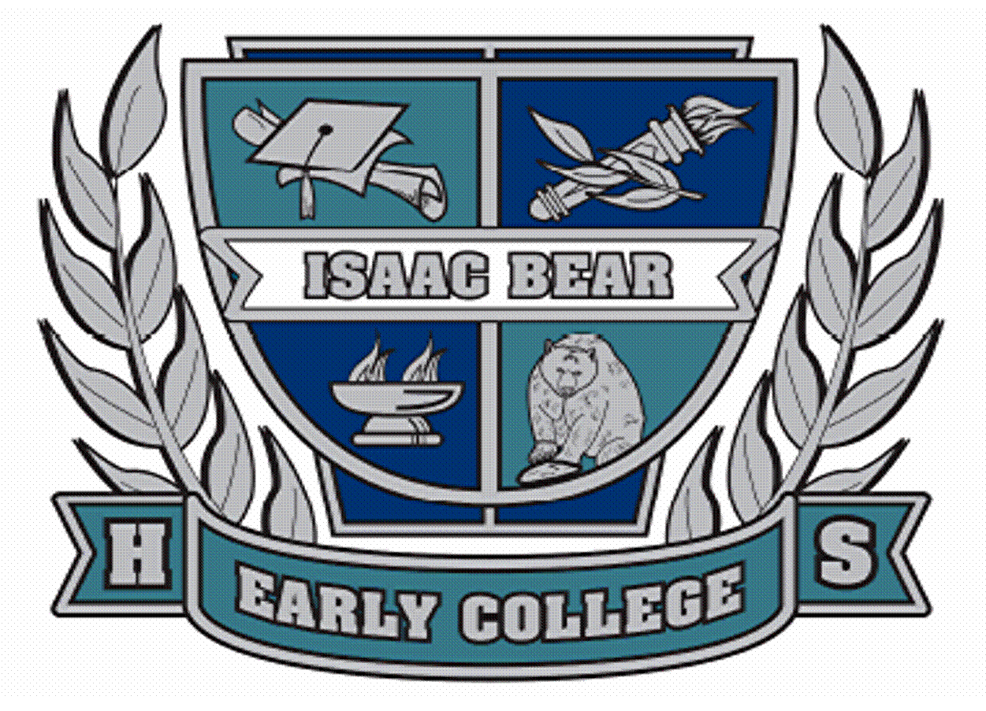

630 MacMillan Ave Mr. Ronald Villines
Wilmington, NC 28403 Principal
Phone: (910) 350-1387 Mrs. Liz Jones
Fax: (910) 350-1392 Assistant Principal

1. GRADUATION PRACTICE--
WHEN: MAY 18, 2021 - 5:00 pm –
WHERE: MINNIE EVANS ARTS CENTER –
This is mandatory for all graduates to attend.
STUDENTS SHOULD REPORT TO FACULTY LEADER FOR LINE UP
· SEE ATTACHED LISTING

2. GRADUATION TICKETS --
- Each student shall receive 4 tickets
- PICK UP TICKETS - EITHER
- 5/5/2021 at IBECHS Senior Social, OR
- 5/18/2021 at Graduation Rehearsal

3. GRADUATION CEREMONY INFORMATION--
A. TIME AND LOCATION:
Wednesday May 19, 2021 at 6:30 pm
at Minnie Evans Arts Center
B. ARRIVAL: 5:45 pm –
Minnie Evans Arts Center - Chorus Room 813.
Students please report to the Faculty for Attendance.
Students should carry cap and gown into the Arts Center.
NHC Sheriff's Office will conduct security scanning.
Personnel will conduct health screening.
C. PARKING: Ashley High School and Murray Middle School

D. STUDENT DRESS CODE FOR GRADUATION CEREMONY:
Please wear Business Formal Attire. Dress Shoes for ALL.
· NO FLIP FLOPS, SNEAKERS, SHORTS, OR LIKE CASUAL ATTIRE.
· PLEASE NO CHEWING GUM.

E. CAP AND GOWN:
- Students should carry their cap and gown into the Arts Center/Chorus Room. New Hanover County Sheriff’s Office will be conducting security scanning.
  - Bring pins/bobby pins to secure collars and caps.
Note: TASSEL goes to the right prior to graduation.
REMINDER: Make sure to hang up your gown to allow
wrinkles to fall out!
F. LINE UP:
- Students should report to their assigned Faculty Leader promptly at 5:45 pm on 5/19/2021.
- They will give you your name card to hand to the announcer on stage to receive your diploma.

G. DIPLOMAS: Students will receive their actual diploma on stage.
- PLEASE BE CAREFUL IN CARRYING DIPLOMA OFF STAGE AS THERE IS A WALLET SIZED LAMINATED DIPLOMA THAT COULD EASILY FALL OUT.

WHAT NOT TO BRING:
- Do NOT bring any personal belongings, including cell phones and other electronic devices, purses or cameras. There is no place to store them.
PLEASE DO NOT TOSS CAPS OR FLOWERS at the end of the ceremony.

H. INFORMATION FOR PARENTS
ARRIVAL: DOORS OPEN AT 5:45 pm and CLOSE at 6:25 pm.
- You may arrive at Minnie Evans Arts Center for the Graduation Ceremony between 5:45 and 6:25 pm.
- Each group of 4 will be seated together in an assigned group seating section.
- REMINDER: New Hanover County Sheriff’s Office will be conducting security scanning - no pocket knives please.
- Parents/Guests please do not walk toward the stage to photograph your graduate as he or she receives his or her diploma.
- Parents/Guests please remain in your seats until all graduates and faculty and staff have processed out of Minnie Evans Arts Center.
- PARKING: Ashley HS Lot/ Murray MS Lot.
- Parents: Please check IBECHS web page under “Links” for additional graduation information.

F. GRADUATION TICKET INFORMATION:
- Each Student can pick up his/her 4 Graduation tickets on either:
- May 5 at Senior Social, or
- on May 18 at Graduation Rehearsal.

- PLEASE NOTE: Tickets will not be issued to those students with PAST DUE BILLS. YOU MUST CLEAR PAST DUE BILLS before you can receive tickets.

- EACH GUEST - INCLUDING BABIES AND SMALL CHILDREN MUST HAVE A TICKET TO ENTER MINNIE EVANS ARTS CENTER.
- NO ONE WILL ENTER WITHOUT A TICKET.

