ISAAC BEAR EARLY COLLEGE HIGH SCHOOL
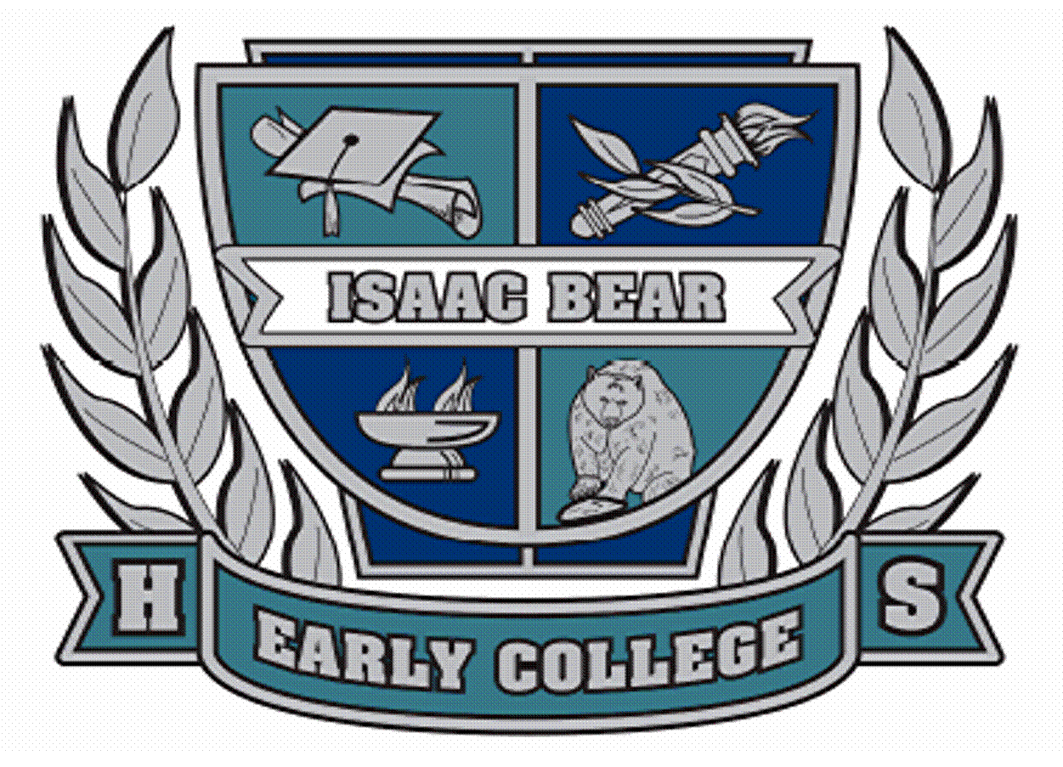

630 MacMillan Ave Mr. Ronald Villines
Wilmington, NC 28403 Principal
Phone: (910) 350-1387
Fax: (910) 350-1392

1. GRADUATION PRACTICE--
WHEN: MAY 17, 2022 - 5:00 pm –
WHERE: KENAN AUDITORIUM –
This is mandatory for all graduates to attend.
STUDENTS SHOULD REPORT TO FACULTY LEADER FOR LINE UP. See list at the end of this document for the lineup.
2. GRADUATION TICKETS --
- Each student shall receive 10 tickets
STUDENTS CAN PICK UP TICKETS
- 5/17/2021 at Graduation Rehearsal
3. SENIOR BANQUET –
WHEN: MAY 17, 2022 – 6:00 pm –
WHERE: BURNEY CENTER
THIS BANQUET IS FOR SENIOR STUDENTS ONLY AND IMMEDIATELY FOLLOWS REHEARSAL. Please dress in appropriate attire.
We will have a celebratory sit down dinner buffet.
We will have a Guest Speaker.
*NOTE: National Honor Society Stoles will be distributed at the Banquet.
Honor Cords will be distributed at the Banquet.

4. GRADUATION CEREMONY INFORMATION--
A. TIME AND LOCATION:
Friday, May 20, 2022 at 6:30 pm
at Kenan Auditorium, UNCW Campus
B. ARRIVAL: 5:30 pm – DeLoach Hall
Students should carry cap and gown into DeLoach Hall.
NHC Sheriff's Office will conduct security scanning.
Personnel will conduct health screening.
C. PARKING: UNCW CAMPUS LOT ADJACENT TO KENAN AUDITORIUM.
D. STUDENT DRESS CODE FOR GRADUATION CEREMONY:
Please wear Business Formal Attire
- Collared shirt w/tie, long pants & dress shoes
- Dresses (should not exceed the length of the graduation gown)
· NO FLIP FLOPS, SNEAKERS, SHORTS, OR LIKE CASUAL ATTIRE.
· NO CHEWING GUM.
E. CAP AND GOWN:
- Students should carry their cap and gown into DeLoach Hall.
New Hanover County Sheriff’s Office will be conducting security scanning.
  - Bring pins/bobby pins to secure collars and caps.
Note: TASSLE goes to the right prior to graduation.
REMINDER: Make sure to hang up your gown to allow wrinkles to fall out!

F. LINE UP:
- Students should report to their assigned Faculty Leader promptly at 5:45 pm on 5/20/2022 in DeLoach Hall.
- Faculty Leader will give you your name card to hand to the announcer on stage to receive your diploma.

G. DIPLOMAS: Students will receive their actual diploma on stage.
- PLEASE BE CAREFUL IN CARRYING DIPLOMA OFF STAGE AS THERE IS A WALLET SIZED LAMINATED DIPLOMA THAT COULD EASILY FALL OUT.
WHAT NOT TO BRING:
- Do NOT bring any personal belongings. There is no place to store them.
PLEASE DO NOT TOSS CAPS OR FLOWERS at the end of the ceremony.

H. INFORMATION FOR PARENTS
ARRIVAL: DOORS OPEN AT 5:45 pm and CLOSE at 6:25 pm.
- You may arrive at Kenan Auditorium for the Graduation Ceremony between 5:45 and 6:25 pm. Doors close at 6:25, so please make sure you are on time.
- REMINDER: New Hanover County Sheriff’s Office will be conducting security scanning - no pocket knives please.
- Parents/Guests please do not walk toward the stage to photograph your graduate as he or she receives his or her diploma.
- Parents/Guests please remain in your seats until all graduates and faculty and staff have processed out of Kenan Auditorium.
- PARKING: UNCW Lot Adjacent to Kenan Auditorium.
- Parents: Please check IBECHS webpage under “Links” for Additional Information.
F. GRADUATION TICKET INFORMATION:
- Each Student can pick up his/her 10 Graduation tickets on May 17 at Graduation Rehearsal.

- PLEASE NOTE: Tickets will not be issued to those students with PAST DUE BILLS. YOU MUST CLEAR PAST DUE BILLS before you can receive tickets.
- EACH GUEST - INCLUDING BABIES AND SMALL CHILDREN MUST HAVE A TICKET TO ENTER KENAN AUDITORIUM.

- NO ONE WILL ENTER WITHOUT A TICKET.

BISHOP (B1) DeLoach Left Hallway | SEAT
- MARSHAL SAMANTHA JOHNSON  - Kristan Allen  - Jossie Altamirano Sosa  - Grayson Brinkley  - Jessica Brinkley  - Leporia Byas  - Pandora Clews  FACULTY- BARBARA GRAHAM  - Katie Crouch  - Tamyra Davis  - Nathan Decatur  FACULTY- LETISHA KIRBY  - John Dinkins  - Kade Downen  - Reef Dunker  - MARSHAL- MAX WANG | A114 Lead In/Out  A113  A112  A111  A110  A109  A108  A107  A106  A105  A104  A103  A102  A101 CENTER FR RG
MICALLEF (B2) DeLoach Right Hallway | SEAT
- MARSHAL- ELLA FITZGERALD  - Maylene Hemingway  - Justin Guo  - Lillian Griffin  - Briana Griffin  - Michael Gregory  FACULTY- MARY MASON  - Joshua Green  - Vivian Gina  - Stella Garrabrant  STAFF- TRACY MOORE  - Macie Fitzgerald  - Mariah Fife  - Noa Ferigo  - Celia Fennell  - Alisha Fariz  - MARSHAL- JACKSON BENFIELD | B101 Lead In/out  B102  B103  B104  B105  B106  B107  B108  B109  B110  B111  B112  B113  B114  B115 CENTER FL RG

C. TAYLOR (B9) DeLoach Left Hallway | SEAT
- MARSHAL- JULIA LAURSEN  - DeyShawn Hooper  - Francis Humphrey  - Katherine Johnson  - Natalie Kermon  - Lindsey Knepper  STAFF- RENEE THEOPHILOS  - Teagan Lauffenburger  - Amelia Laursen  - Grayson Lynch  FACULTY- MOLLY NEEDHAM  - Fadeyah Mansour  - Sable Marshburn  - Eleanor Meinhold  - Miranda Nguyen  - MARSHAL- NATALIE SMITH  - MARSHAL- JADRIEN LORA | C115 Lead in/out  C114  C113  C112  C111  C110  C109  C108  C107  C106  C105  C104  C103  C102 FAR BR RG  C101 CENTER BR RG
SPEAR (B8) DeLoach Right Hallway | SEAT
- MARSHAL- JONATHAN RAMIREZ  - Rylee Sherwood  - Leana Rayyan  - Ociel Ramirez Martinez  - Emmalee Pinto  - Ian Peplow  - Callum Pearson-Dunaj  FACULTY- KITT STARNES  - Sanda Parada Parada  - Ugochukwu Odibo  - Evian Oates  - Patrick O’Dacre  FACULTY- DANIEL WALTER  - Nina Noble  - Alana Nyers  - MARSHAL- NATHALIE ESCALANTE  - MARSHAL- KENNY YEPEZ | D101 Lead in/out  D102  D103  D104  D105  D106  D107  D108  D109  D110  D111  D112  D113  D114 FAR LF RG  D115 CENTER BL RG
MANNION (B13) DeLoach Left Hallway | SEAT
- MARSHAL- HARRISON LENNON  - Connor Sneed  - Robert Spencer  - Meredith St. Pierre  FACULTY- DANIELLE TALBERT  - Zachary Terault  - Anthony Toloczko  - Nicholas Toloczko  - Varun Varadarajan  FACULTY- ROCHELLE WATERS  - Xin Ge Wu  - Julian Zagazeta  - Michelle Zhang  - MARSHAL- BETSY YOUNG  - MARSHAL- CHRISTINA COUNTS  - MARSHAL- LAUREN WILSON  - MARSHAL- SHANE CHEUNG | E115 Lead in/out  **Row A  E114  E113  E112  E111  E110  E109  E108  E107  E106  E105 PROGRAMS  E104 PROGRAMS  E103 FAR FR RG  E102 FAR BL RG

